Alyn Hospital

Gait Visualization System

User manual

Introduction
There is a need for developing a video system which will help mechanotherapists to analyze the gait of young patients in Alyn Children Rehabilitation hospital.
The Gait Visualization System is a video system based on multiple cameras, to be used in a dedicated room. The patient is instructed to walk a few meters in the room, while a set of synchronized cameras records his motion through the room. The resulting video clips are then simultaneously displayed on a common computer screen, so the mechanotherapists can review and diagnose the details of the patient's body movements.

General Architecture
The proposed system consists of four video cameras (shutter visual sensors). One of the cameras is lateral, two are frontal, and one is rear. Each camera is controlled by a single-board computer (SBC) RaspberryPi 4. Each camera records a single video stream and stores it in local storage of the corresponding SBC. The cameras are interconnected through a standard wired ethernet network. A dedicated PC reads the video streams and displays them contiguously on screen.
See the diagram below:
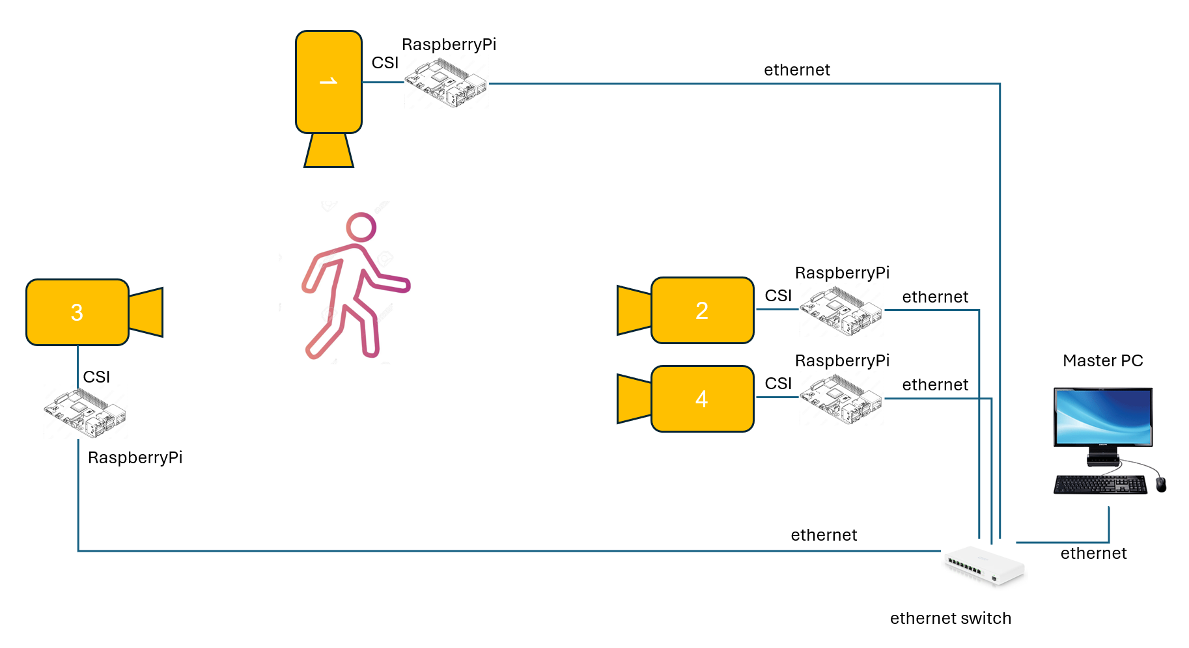

Functionality

Running PC software
- Go to project directory, e.g.:
"C:\Users\<user>\OneDrive\מסמכים\Alyn\gait analysis"
- Go to PC subdirectory:
cd PC
- Open a cmd window
- Run the sync service:
python3 time_server.py
- Then activate the software by entering the following command:
python3 get_stream_capture_from_multiple_rpis.py
- Choose between the available modes as below
The mode selection can be either by graphic interface or by command line (see below). This is determined by "GUI_mode" field in configuration file.
In graphic mode, the main window is as follows:
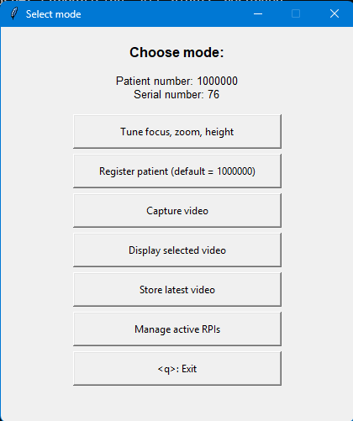

Modes of operation
User is asked to choose between the following modes of operation:
1: Tune focus, zoom, height
In this mode, the user is asked to choose one of the cameras, then the camera is streamed to user's screen. This allows the user to fine-tune the focus, the optical length of the zoom (if necessary) and the angle and height of the camera. To exit the mode, the user must click on the picture, and to type "q".
2: Register patient (default = 1000000)
In this mode, the user shall enter the patient's file number, thus facilitating tracking of the patient's video takes.
3: Capture video
In this mode, all the cameras are triggered simultaneously to start video capture. User is asked to set the duration of the video capture. If user selects "0", then a small widget is open, and the video taking will be active until the user presses the "stop" button.
4: Display selected video
In this mode, the user can watch stored video clips. User is shown a list of recent video clips; the user can see a specific set as determined by the serial number of the take, and the patient's file number.
5: Store latest video
In this mode, the latest video set is automatically saved into a directory dedicated to the specific patient's file number.
6: Manage active RPIs
In this mode the user can activate or de-activate each camera.

Configuration
The system's configuration is set by file named rpi_config.json.
The file shall be edited before running the application.
Example:
{
"rpi5_name": "gait5",
"rpi5_IP": "192.168.50.15",
"rpi2_name": "gait2",
"rpi2_IP": "192.168.50.12",
"rpi3_name": "gait3",
"rpi3_IP": "192.168.50.13",
"rpi4_name": "gait4",
"rpi4_IP": "192.168.50.14",
"GUI_mode": "GUI",
"rpi_active": [
"rpi4",
"rpi5"
],
"rpi_select": "rpi4",
"rpi_sync_server": "rpi4"
"fileNumber": "1000000",
"duration": null,
}
- "GUI mode" selects either "GUI" (graphic interface) or "command line"
- "rpi_active" lists the active cameras
- "rpi_select" indicates the rpi which is selected for streaming in tuning mode
- "rpi_sync_server" indicates the master rpi for synchronization (not in use)

File system
The video files are saved in the directory:
"C:\Users\<user>\OneDrive\מסמכים\Alyn\gait analysis\video"
If the user asks for saving specific files, they are saved in a subdirectory named as patient file number.

